A000-AM,S-Peru-Moche-Stirrup Bottle-Tumi Design-Ceramic-200-400 CE

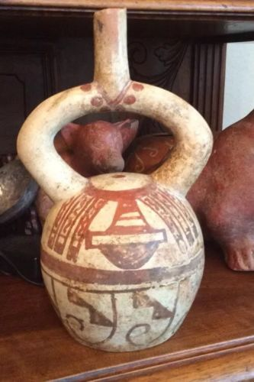

Fig. 1. Peru-Moche-Stirrup Bottle-Tumi Design-Ceramic-200-400 CE.

Case No: 10

This vessel is thought to have been used in ceremonies in which a shaman would assume the rôle of the supernatural jaguar, the emblematic mask of the Fanged Deity or Decapitator. Decapitator was responsible for decapitating the victim with the tumi or crescent-shaped metal knife with its curved blade. On this red ceramic panel it is depicted flanked by two rows of three descending zigzags of blood pouring forth (symbols or proto-hieroglyphs?).

Below is depicted the three ritual staircase steps, which the Decapitator and his victim would surmount to perform the decapitation and collection of the victim’s blood which would then be poured into this bottle.

Surmounting this bottle is the spout, which is the metaphoric Decapitator, headless, with a necklace displaying 4 gemstones, possibly red rubies. Descending from the spout is Decapitator’s arms which are extended akimbo until they touch the bottle, which now becomes Decapitator’s body—filled with the victim’s blood. Decapitator is the master of the spirit world and the feline patron deity of warriors and shamans. This deity reigned over western South America for at least 2000 years and still survives today.

**LC Classification:** F3430.1.

**Date or Time Horizon:** 200-400 CE.

**Geographical Area:** NW coastal Peru

**Map, GPS coordinates: -6.80139 -79.60202; 6º48'5" S 79º36'7.28" W.**

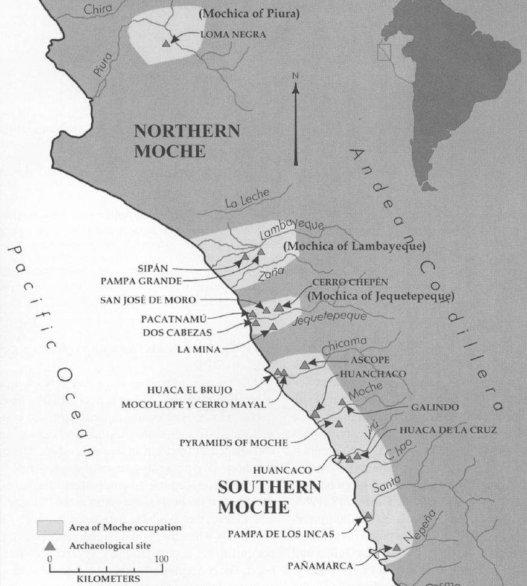

Fig. 6. Map of Moche regions as currently conceived and significant Moche sites. Map courtesy Moro Archaeological program.

**Cultural Affiliation:** Moche, Mochica

**Media:** clay; polychrome colors: red, cream, black, skin color

**Dimensions:** H mm; in

**Weight: gm; oz**

**Condition: original**

**Provenance:** unknown

**Discussion: (Attributed to Wiki)**

Some (Christopher B. Donnan and Izumi Shimada) argue that these sacrificial victims were ritual losers of battles among local élites, while others (John Verano and Richard Sutter), suggest that these sacrificial victims were actual warriors captured in territorial battles with other nearby cultures. Excavations in plazas near Moche huacas have found groups of people sacrificed together and the skeletons of young men deliberately excarnated or denuded of all skin and even flesh perhaps for temple displays of their skeletons.

Moche society was agriculturally based, with a significant level of investment for: 1) the construction of a network of irrigation canals for the diversion of river water to supply their crops and .2) the development of ateliers for both metal smiths and ceramicists. This latter investment culture produced a sophisticated society in which artifacts express their lives including sacrificial rituals like this bottle jar with its elaborately painted motifs, which hint at a developing symbolism that may have had hieroglyphic implications (Beck et al. 1999).

Both iconography such as on this ritual bottle and the finds of human skeletons in ritual contexts seem to indicate that human sacrifice and the issuance and capturing of blood in bottle like this one played a significant rôle in Moche religious ceremonies. These rites appear to have involved an élite cadre of key ceremonial, costumed participants within a monumental setting followed by the ritual consumption of blood.

**Provenance:**

Garcia Fernandez collected this ceramic while living in Peru 1950-1980.

**Discussion:**

**References:**

Alva, Waltsr and Chrisopher R. Donnan. 1993. *Royal Tombs of Sipan*, Fowler Museum of Cultural History, Los Angeles: UCLA.

[Anon.](https://en.wikipedia.org/wiki/Moche_culture#cite_ref-4)  [The Salinar Culture](http://www.tampere.fi/ekstrat/taidemuseo/arkisto/peru/800/salinar_en.htm) Tampere Museum

Bawden, G. 2004. "The Art of Moche Politics". In Silverman, H. **Andean Archaeology**. Oxford: Blackwell Publishers.

Beck, Roger B.; Black, Linda; Krieger, Larry S.; Naylor, Phillip C.; Shabaka, Dahia Ibo. 1999. World History: Patterns of Interaction. Evanston, IL: McDougal Littell.

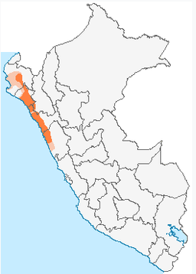

Peru, Moche or Mochica culture

Ceramic, buff clay with brown, red, and cream slip

Moche painted Stirrup Bottle from Peru, ca. 200-400 AD-CE with a cream slip ground and painted in orange, brown, and rare purple/ plum paints. The round body features an orange band at the center with a purple band above having pointed designs, and on the upper body of the vessel is an intertwined undulating band with long effigies with bird heads and long plumed bodies. A very colorful bottle with a rarely found paint color.

**Tumi sacrificial knife**

**Origins**

The origins of the tumi is found in the Moche culture. According to one source, the word ‘tumi’ is derived from the language of the Moche people. Based on oral tradition, the Moche are said to have been navigating along the Chancay River in order to find a suitable place to settle down. Whilst they were travelling along the river, they spotted some sea lions on a shore. They took this as a divine sign, and decided to make their home there. Apparently in their language the word for sea lion was ‘tumi’. As these sea lions were regarded as a sign form the gods, the word ‘tumi’ took on a divine association from then on.